Lab – 4

Communication Protocol Case Study – MQTT (Mosquitto)
1. Aim
To study the MQTT communication protocol and understand broker-based messaging using Mosquitto.

2. Theory
MQTT (Message Queuing Telemetry Transport) is a lightweight publish-subscribe communication protocol used in IoT applications.
Key components:
- Publisher: Sends messages
- Subscriber: Receives messages
- Broker: Manages communication
Mosquitto is an open-source MQTT broker widely used for IoT systems.
Advantages:
- Low bandwidth usage
- Lightweight communication
- Efficient for IoT devices

3. Apparatus / Requirements
- Computer system
- Internet connection
- Mosquitto
- MQTT client software

4. Block Diagram
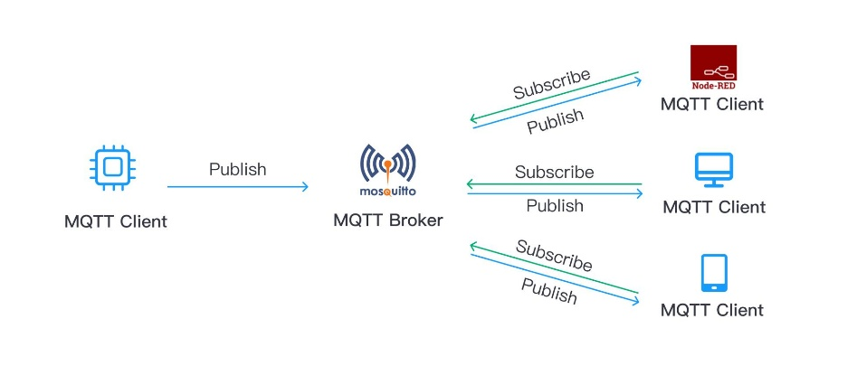

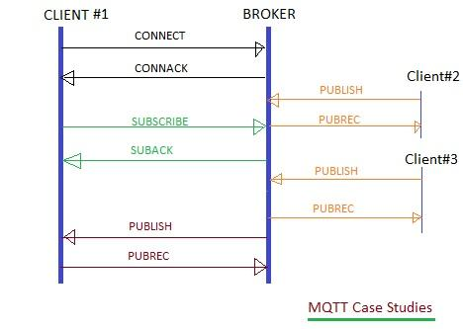

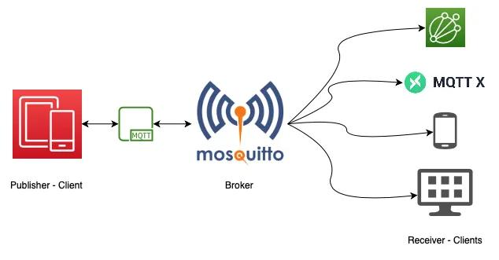

5. Procedure
- Install Mosquitto broker
- Start broker service
- Open two terminals
- Subscribe to a topic using subscriber command
- Publish message from another terminal
- Observe received message

6.Program / Code

Subscriber

Publisher

7. Observations / Readings
- Broker established communication
- Published messages received successfully
- Real-time message transfer observed

8. Result
MQTT communication using Mosquitto broker was successfully studied and implemented.

